1. Suppose you play the game of shooting. You shoot 6 times, each time to a different enemy, and each shot has a 10% chance of success.

1) What's the probability of killing two enemies out of six?

2) What's the probability of killing at most three enemies out of six?

3) What's the maximum number of enemies we can kill with 90% probability?

2. Suppose there is only one enemy and two success shots can kill the enemy. Each shot has a 10% chance of success. How many times do you need to shoot to kill the enemy with 80% probability?

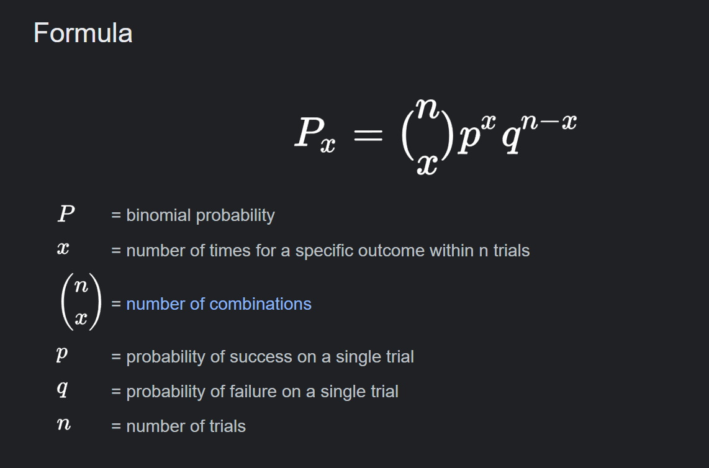

Q1

1. P(X = k) = (n choose k) \* p^k \* (1 - p)^(n - k)  
   C(6, 2) = 6! / (2! \* (6 - 2)!) = 15  
   P(X = 2) = 15 \* (0.1^2) \* (0.9^(6 - 2))  
   P(X = 2) = 15 \* 0.01 \* 0.6561  
   P(X = 2) = 9.8415%
2. P(X = 1):

P(X = 1) = (6C1) \* (0.10)^1 \* (0.90)^5 = 6 \* 0.10 \* 0.59049 = 0.3542946

P(X = 2):

P(X = 2) = (6 choose 2) \* (0.1^2) \* (0.9^4) = 15 \* 0.01 \* 0.6561 = 0.98415

P(X = 3):

P(X = 3) = (6 choose 3) \* (0.1^3) \* (0.9^3) = 20 \* 0.001 \* 0.729 = 0.01458

P(X ≤ 3) = 0.531441 + 0.354294 + 0.98415 + 0.01458 ≈ 1.884465  
P(X ≤ 3) = P(X = 1) + P(X = 2) + P(X = 3)  
P(X ≤ 3) = 0.3542946 + 0.098415 + 0.01458  
P(X ≤ 3) = 0.4672896 or 46.73%

For k = 1:

P(X ≤ 1) = P(X = 0) + P(X = 1)

P(X ≤ 1) = (6C0) \* (0.10)^0 \* (0.90)^6 + (6C1) \* (0.10)^1 \* (0.90)^5

P(X ≤ 1) = 0.531441 + 0.3542946

P(X ≤ 1) = 0.8857356  
For k = 2:

P(X ≤ 2) = P(X ≤ 1) + P(X = 2)

P(X ≤ 2) = 0.8857356 + (6C2) \* (0.10)^2 \* (0.90)^4

P(X ≤ 2) = 0.8857356 + 0.098415

P(X ≤ 2) = 0.9841506

For k = 3:

P(X ≤ 3) = P(X ≤ 2) + P(X = 3)

P(X ≤ 3) = 0.9841506 + (6C3) \* (0.10)^3 \* (0.90)^3

P(X ≤ 3) = 0.9841506 + 0.01458

P(X ≤ 3) = 0.9987306 or 99.87%  
So you can kill at most 3 enemies

Q2

1. P(X = k) = (1 - p)^(k-1) \* p  
     
   k until P(X ≤ k) is at least 80%:

P(X = 1) = (1 - 0.10)^(1-1) \* 0.10 = 0.10  
  
calculate the cumulative probabilities:

P(X ≤ 1) = 0.10

P(X = 2) = (1 - 0.10)^(2-1) \* 0.10 = 0.09

P(X ≤ 2) = 0.10 + 0.09 = 0.19

P(X = 3) = (1 - 0.10)^(3-1) \* 0.10 = 0.081

P(X ≤ 3) = 0.10 + 0.09 + 0.081 = 0.271

P(X = 4) = (1 - 0.10)^(4-1) \* 0.10 = 0.0729

P(X ≤ 4) = 0.10 + 0.09 + 0.081 + 0.0729 = 0.3439

P(X = 5) = (1 - 0.10)^(5-1) \* 0.10 = 0.06561  
P(X ≤ 5) = 0.10 + 0.09 + 0.081 + 0.0729 + 0.06561 = 0.40951

P(X = 6) = (1 - 0.10)^(6-1) \* 0.10 = 0.059049  
P(X ≤ 6) = 0.10 + 0.09 + 0.081 + 0.0729 + 0.06561 + 0.059049 = 0.468559

P(X = 7) = (1 - 0.10)^(7-1) \* 0.10 = 0.0531441

P(X ≤ 7) = 0.10 + 0.09 + 0.081 + 0.0729 + 0.06561 + 0.059049 + 0.0531441 = 0.5217031

P(X = 8) = (1 - 0.10)^(8-1) \* 0.10 = 0.04782969

P(X ≤ 8) = 0.10 + 0.09 + 0.081 + 0.0729 + 0.06561 + 0.059049 + 0.0531441 + 0.04782969 = 0.56953279

P(X = 9) = (1 - 0.10)^(9-1) \* 0.10 = 0.043046721

P(X ≤ 9) = 0.10 + 0.09 + 0.081 + 0.0729 + 0.06561 + 0.059049 + 0.0531441 + 0.04782969 + 0.043046721 = 0.612579511

P(X = 10) = (1 - 0.10)^(10-1) \* 0.10 = 0.0387420489  
P(X ≤ 10) = 0.10 + 0.09 + 0.081 + 0.0729 + 0.06561 + 0.059049 + 0.0531441 + 0.04782969 + 0.043046721 + 0.0387420489 = 0.65132156

P(X = 11) = (1 - 0.10)^(11-1) \* 0.10 = 0.03486784401  
P(X ≤ 11) = 0.10 + 0.09 + 0.081 + 0.0729 + 0.06561 + 0.059049 + 0.0531441 + 0.04782969 + 0.043046721 + 0.0387420489 + 0.03486784401 = 0.686189404

P(X = 12) = (1 - 0.10)^(12-1) \* 0.10 = 0.03138105961  
P(X ≤ 12) = 0.10 + 0.09 + 0.081 + 0.0729 + 0.06561 + 0.059049 + 0.0531441 + 0.04782969 + 0.043046721 + 0.0387420489 + 0.03486784401 + 0.03138105961 = 0.717570464

P(X = 13) = (1 - 0.10)^(13-1) \* 0.10 = 0.02824295365  
P(X ≤ 13) = 0.10 + 0.09 + 0.081 + 0.0729 + 0.06561 + 0.059049 + 0.0531441 + 0.04782969 + 0.043046721 + 0.0387420489 + 0.03486784401 + 0.03138105961 + 0.02824295365 = 0.7458134177

P(X = 14) = (1 - 0.10)^(14-1) \* 0.10 = 0.02541865829

P(X ≤ 14) = 0.10 + 0.09 + 0.081 + 0.0729 + 0.06561 + 0.059049 + 0.0531441 + 0.04782969 + 0.043046721 + 0.0387420489 + 0.03486784401 + 0.03138105961 + 0.02824295365 + 0.02541865829 = 0.771232076

P(X = 15) = (1 - 0.10)^(15-1) \* 0.10 = 0.02287879246

P(X ≤ 15) = 0.10 + 0.09 + 0.081 + 0.0729 + 0.06561 + 0.059049 + 0.0531441 + 0.04782969 + 0.043046721 + 0.0387420489 + 0.03486784401 + 0.03138105961 + 0.02824295365 + 0.02541865829 + 0.02287879246 = 0.794110868

P(X = 16) = (1 - 0.10)^(16-1) \* 0.10 = 0.02059191321  
P(X ≤ 16) = 0.10 + 0.09 + 0.081 + 0.0729 + 0.06561 + 0.059049 + 0.0531441 + 0.04782969 + 0.043046721 + 0.0387420489 + 0.03486784401 + 0.03138105961 + 0.02824295365 + 0.02541865829 + 0.02287879246 + 0.02059191321 = 0.814702781

With 16 shots, you have a cumulative probability of 81.47%.  
it takes 16 shots to achieve an 80% probability of killing the enemy